2012 MI PU2 H1 Maths Promo 2 Paper: Suggested Solutions

1(a) | 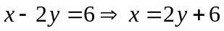  Substitute 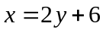 into 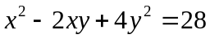  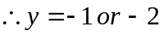  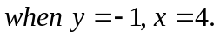  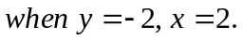
1(b) | 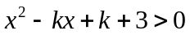  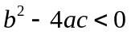  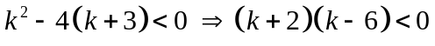  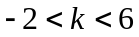
2 | 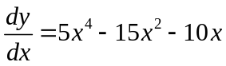  To find stationary points, let =0.  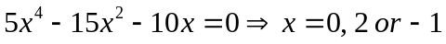  3 stationary points: 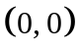, 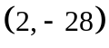, 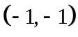.  Use 1st derivative or 2nd derivative test to show the is a maximum point and is a minimum point.  Use 1st derivative test to show that is a point of inflexion.
2 | 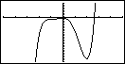
3 | 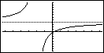
3 | 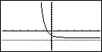
4 | 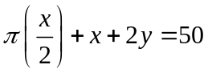  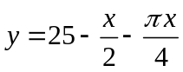  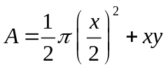  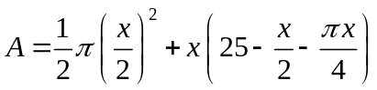  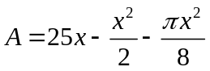  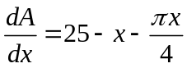  To find maximum points, let =0.  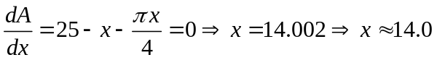  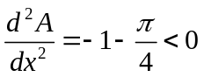,  A is maximum when x=14.0.  Maximum value of A is 175 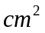
5(a) | 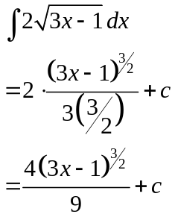
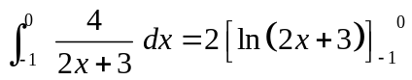
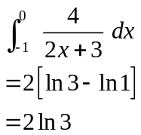

5(b) | 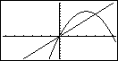
Using GC, the line intersect the curve at x=0 and x=4.
Area of the required region
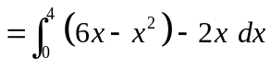
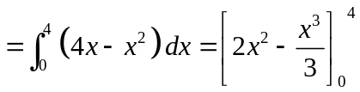
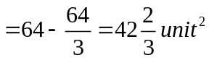

6 | 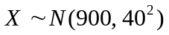  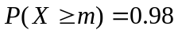  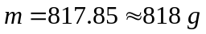
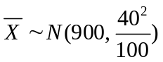
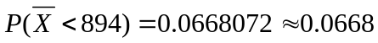
7(i) | Quota sampling.  Quota sampling is biased/ unreliable.
7(ii) | First obtain a list of all the students and assign sequential numbers (1 to 1200) to all of them.  Calculate the sampling interval: 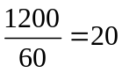.  Then choose a random start by selecting a random number from 1 to 20. Finally select every 20th student subsequently until 60 students are obtained.
7(iii) | Use stratified Sampling.  Select 25 PU1 students, 20 PU2 students and 15 PU3 students.  Use simple random sampling to select the required number of students from each level.
8 | Let X=Number of defective components in a box.  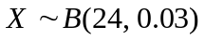  (i) (a)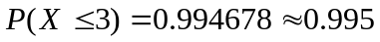  (i) (b)  (ii) Probability=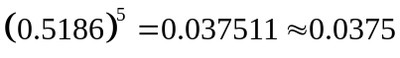  Let Y=Number of boxes each of which contains at least one defective component.  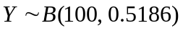  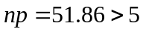 and 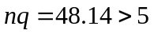  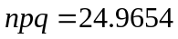  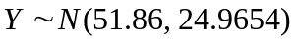
9 | From GC, r = 0.934 (3 s.f.)  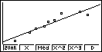  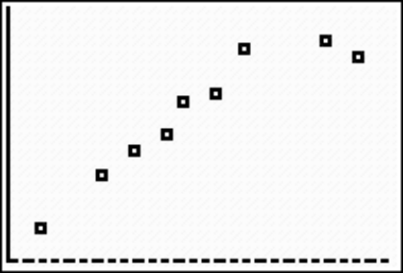
9 | Least square regression of y on x is y = 0.914x + 20.4  Least square regression of x on y is x = 0.955y – 14.0  Now x = 10, using y on x line we have  y = 0.914(10) + 20.4  = 29.5  The estimate is unreliable as it is an extrapolation.
10 | (i) Unbiased estimate of population mean,  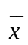= 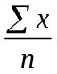 =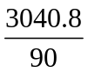= 33.7866 = 33.8 (to 3s.f)  Unbiased estimate of population variance,  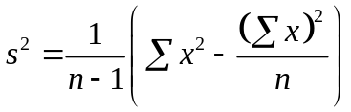= 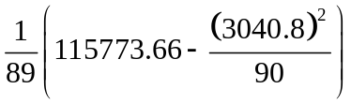= 146.4625 = 146.5 (3s.f)  (ii)  To test 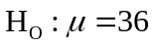  against 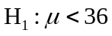 at 1% level of significance  Since n is large, under 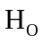, 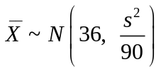 approximately by CLT  Test statistic: 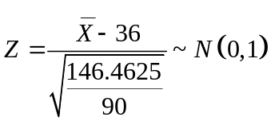  Using G.C, value of test statistic = – 1.73 (3s.f)  p-value = 0.0414 (3s.f)  Since p-value = 0.0414 > 0.01, do not reject .  There is insufficient evidence to conclude at 1% level of significance that the mean standby-time is less than 36 hours.  (iii) As sample size is large and the Central Limit Theorem applies, there is no need to assume a normal distribution for the test to be valid.  (iv) To reject , level of significance > 0.0414.
11(a) | - The event 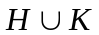 represents the case where the card taken is either a Heart, or a King, or both.  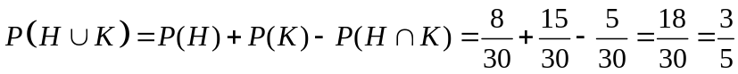  - The event 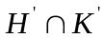 represents the case where the card taken is neither a Heart, nor a King.  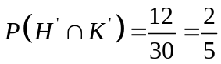
11(b) | 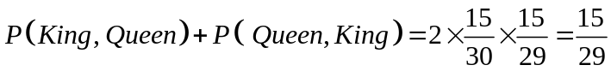  Or 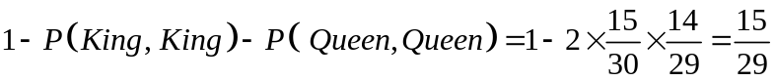
11(c) | Case 1: 3 Kings  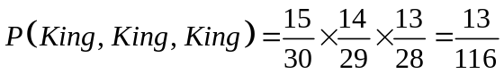  Case 2: 2 Kings  The required probability=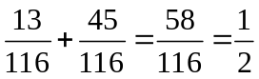
12 (a) | (i) 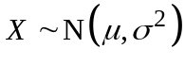  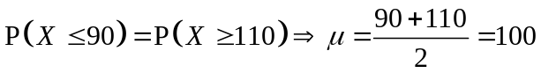  (ii) 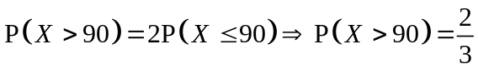  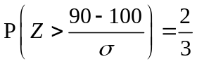  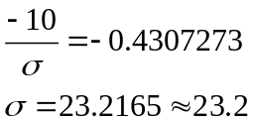
12 (b) | 